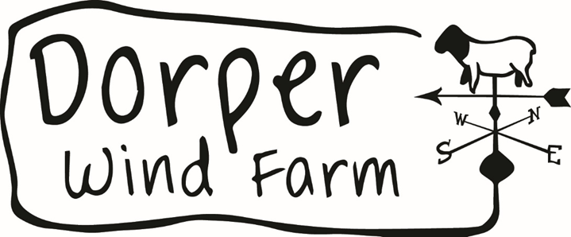

Request For Quotation (RFQ): Early Childhood Development (ECD), Numeracy and Literacy Programme

Contents
1. INTRODUCTION 3
2. SCOPE OF WORK 4
4. RFQ RESPONSE REQUIREMENTS 6
5. EVALUATION CRITERIA 7
6. SUBMISSION GUIDELINES 8
7. CONTRACT TERMS 8
8. TERMS & CONDITIONS 9

- INTRODUCTION AND BACKGROUND

Dorper Wind Farm RF Proprietary Limited (DWF) engages in the design, development, engineering, procurement, construction, financing, commissioning, operation, and maintenance of an onshore wind energy generation facility. The project consists of 40 x 2.5MW Nordex wind turbines and is located just south of Molteno in the Eastern Cape.

In line with its commitments, DWF has economic development obligations within a 50 km radius of the wind farm, specifically targeting the communities of Molteno and Sterkstroom. These obligations include investing in initiatives that promote sustainable socio-economic development and improve the quality of life of local communities. As part of this mandate, DWF aims to support Early Childhood Development (ECD) and foundational learning programmes, with a particular focus on literacy and numeracy. Research has consistently shown that effective learning in Pre-Grade R and Grade R plays a critical role in shaping learner performance throughout the schooling journey, as it equips children with the foundational skills required to meet the literacy and numeracy demands of Grade 1 and beyond. This is particularly important in under-resourced communities, where early interventions are essential in addressing developmental gaps and educational inequalities.

Evidence further indicates that learning challenges that are not addressed during the early years tend to persist and compound over time. International assessments continue to highlight that many learners perform below expected standards for their age and grade levels. Given that learning is cumulative, children who do not acquire foundational literacy and numeracy skills are at a significantly higher risk of falling behind, repeating grades, or ultimately dropping out of school if appropriate support is not provided.

Recognising the importance of getting the fundamentals right, DWF seeks to invest in targeted interventions aimed at strengthening early learning outcomes and improving foundational skills among young children. This project will specifically target 18 local Early Childhood Development (ECD) centres and 7 primary schools, ensuring a coordinated and inclusive approach across both pre-school and early primary education levels. By supporting both ECD centres and primary schools, the initiative aims to create continuity in early learning, strengthen the transition into formal schooling, and build a solid foundation for improved educational outcomes. Ultimately, this investment is intended to contribute to long-term socio-economic development by enabling children in Molteno and Sterkstroom to reach their full learning potential.

- SCOPE OF WORK

The primary objective of this is to improve early childhood development outcomes by strengthening language, literacy, and school readiness among young children in targeted communities through capacity building, resource provision, and community engagement. The specific objectives are to:

- Improve the quality of teaching practices among Pre-Grade R practitioners and Grade R teachers through structured training and mentorship.

- Enhance early language and emergent literacy skills of children to support successful transition into formal schooling.

- Provide access to high-quality, culturally appropriate learning and teaching support materials in isiXhosa and English.
- Strengthen parental and caregiver involvement in children’s learning and promote a culture of reading at home.
- Improve school readiness by ensuring children acquire foundational pre-literacy and numeracy skills.
- Establish an effective monitoring and evaluation system to measure programme implementation, performance, and outcomes.
- Foster collaboration between ECD centres, schools, and community stakeholders to support sustainable early learning interventions.

- RFQ RESPONSE REQUIREMENTS

- Potential Service Provider must provide the following details in their response:
- Company (Name, Address, Contact Person, Website, Years of Experience, Past experience etc.)
- Pricing Schedule (Annexure A) (Itemized cost structure, travel, materials, and communication)
- At least two reference letters (At least two references for work conducted as a company, reference must be on the letterheads of clients)
- Company Registration Documents
- BBBEE Certificate or Sworn Affidavit

- EVALUATION CRITERIA

Only bids that have submitted the required documentation in Section 4: RFQ Response
Requirements, will be evaluated based on the below criteria.

1. BBBEEE Scoring (30%)
- Level 1 = 30%, Level 2 = 25%, Level 3 = 20%, Level 4 = 15%, Level 5 = 10%, Level 6 = 5%, Level 7+ =0%
2. Experience and references (20%)
- 5% for each credible reference letter, with a maximum of 20% total
- DWF reserves the right to verify references
3. Pricing (20%)
- Sliding scale calculation, the lowest (cheapest/best) priced potential Service Provider
scores 20% and highest priced potential Service Provider scores 0%
4. Proposal (30%)
- None = 0%, Poor = 10%, Good = 20%, Very Good =30%

5. SUBMISSION GUIDELINES
- Deadline for Submission:
- Submission Method: Email response requirements (see Section 4) to rfq@dorperwindfarm.co.za. Only submissions via email shall be accepted.
- Point of Contact: rfq@dorperwindfarm.co.za
- Clarification Requests Deadline: all clarifications must be directed to rfq@dorperwindfarm.co.za by 15 July 2026

6. CONTRACT TERMS
- The duration of the contract should indeed be flexible based on the specific needs of the project.
- Compliance with legal and contractual obligations. The preferred Service Provider shall enter into a Service Level Agreement with DWF.
- Payment terms (To be made upon receipt and approval of the monthly report and supporting documents).

7. TERMS & CONDITIONS
- Dorper Wind Farm reserves the right to accept or reject any RFQ responses or to not appoint/award a Service Provider or Candidate
- Validity period of the quotations shall be 60 days
- Compliance with legal and contractual obligations shall be required throughout the contract period

